|  |  |  |  |  |  |
| --- | --- | --- | --- | --- | --- |
| Date | 7-Dec-22 | | | Tester Name | Andrew McLaughlin |
| Environment | Penfax - Test | | | Login used |  |
| Operating System | Windows | Version: | Update: | | |
| Software Used | Edge | Version: | Update: | | |
| Select Software | Version: | Update: | | |
| Release version | 22.4.1 | | | | |
| Title | M46.03 New retiree during year | | | | |
| Test Type | Regression | | | | |
| Test Scenario | M46.03 New retiree during year | | | | |
|  |  | | | | |
| Expected Results |  | | | | |
| Pass/Fail | Pass | | | JIRA# | N/A |

Describe your steps with screenshots:

Run pre-indexing query for PSSP – **Query Available on Page 3 here**: H:\Quality Assurance\Prod Apps\PenfaxV5\MEPP\Procedures\How to Run Indexing in Penfax 5.docx

Apply indexation rate for PSSP with benefits commencing 01-JAN-1900, effective date the day you want them to start, for **every Recipient Type and Income Amount Type**. 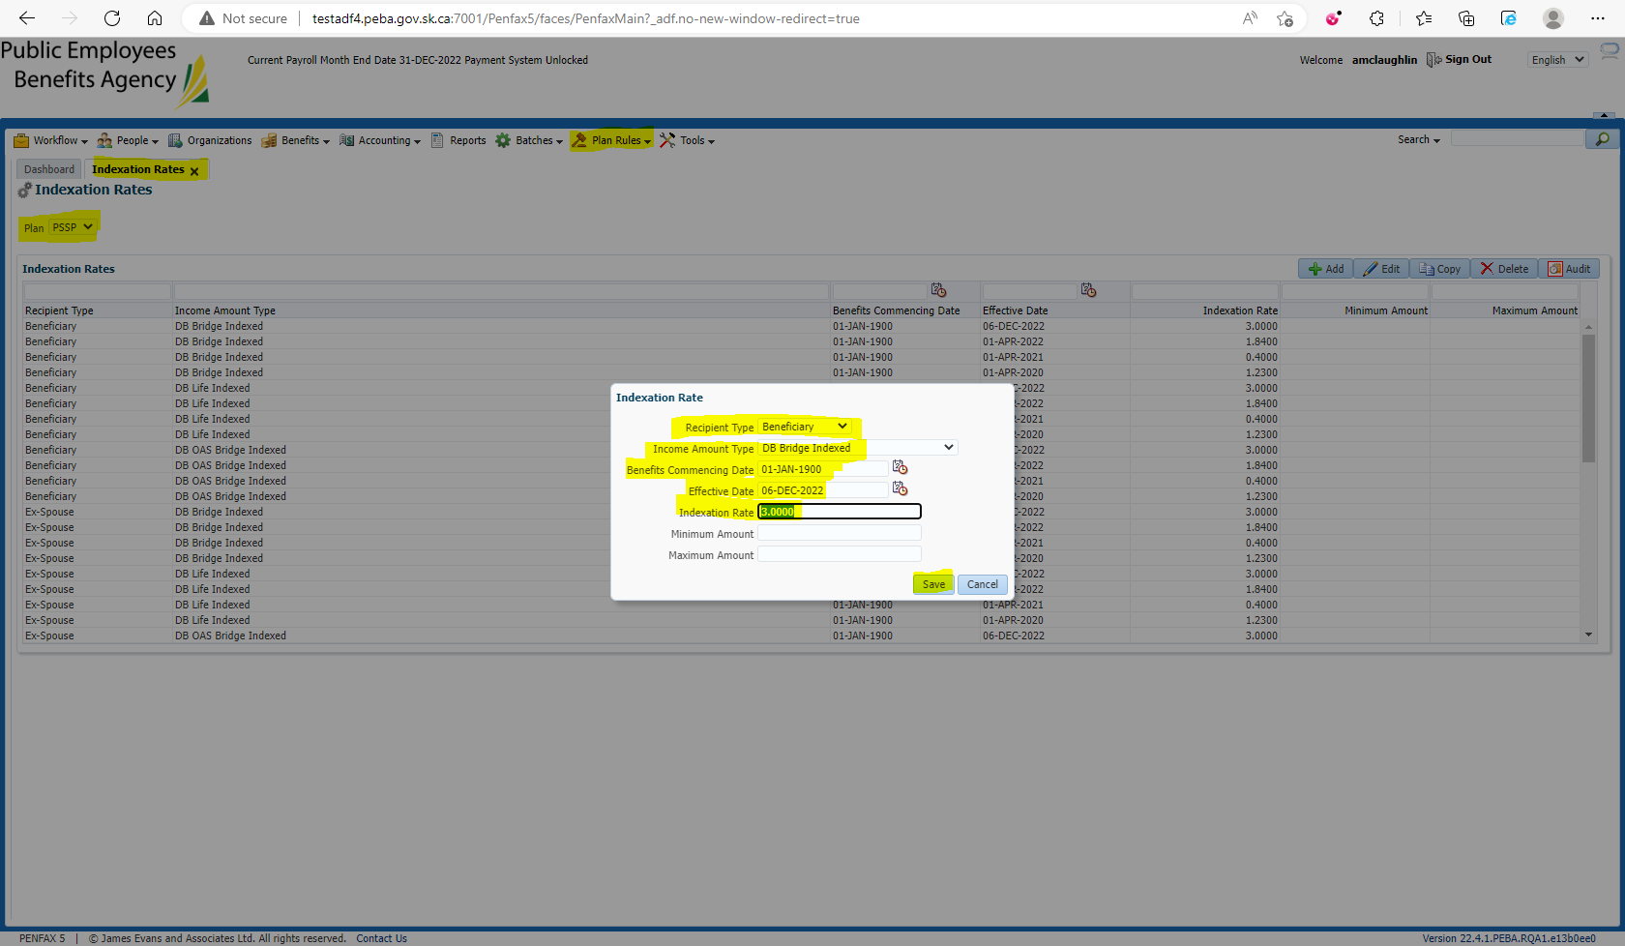

Run the Indexation Batch for the Plan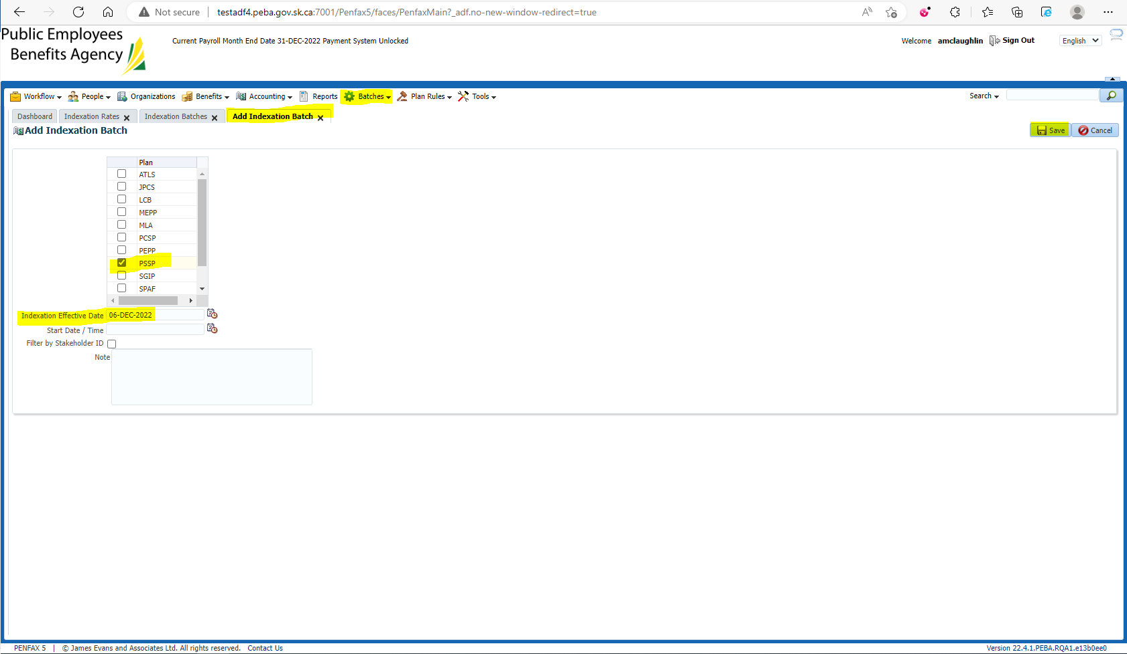

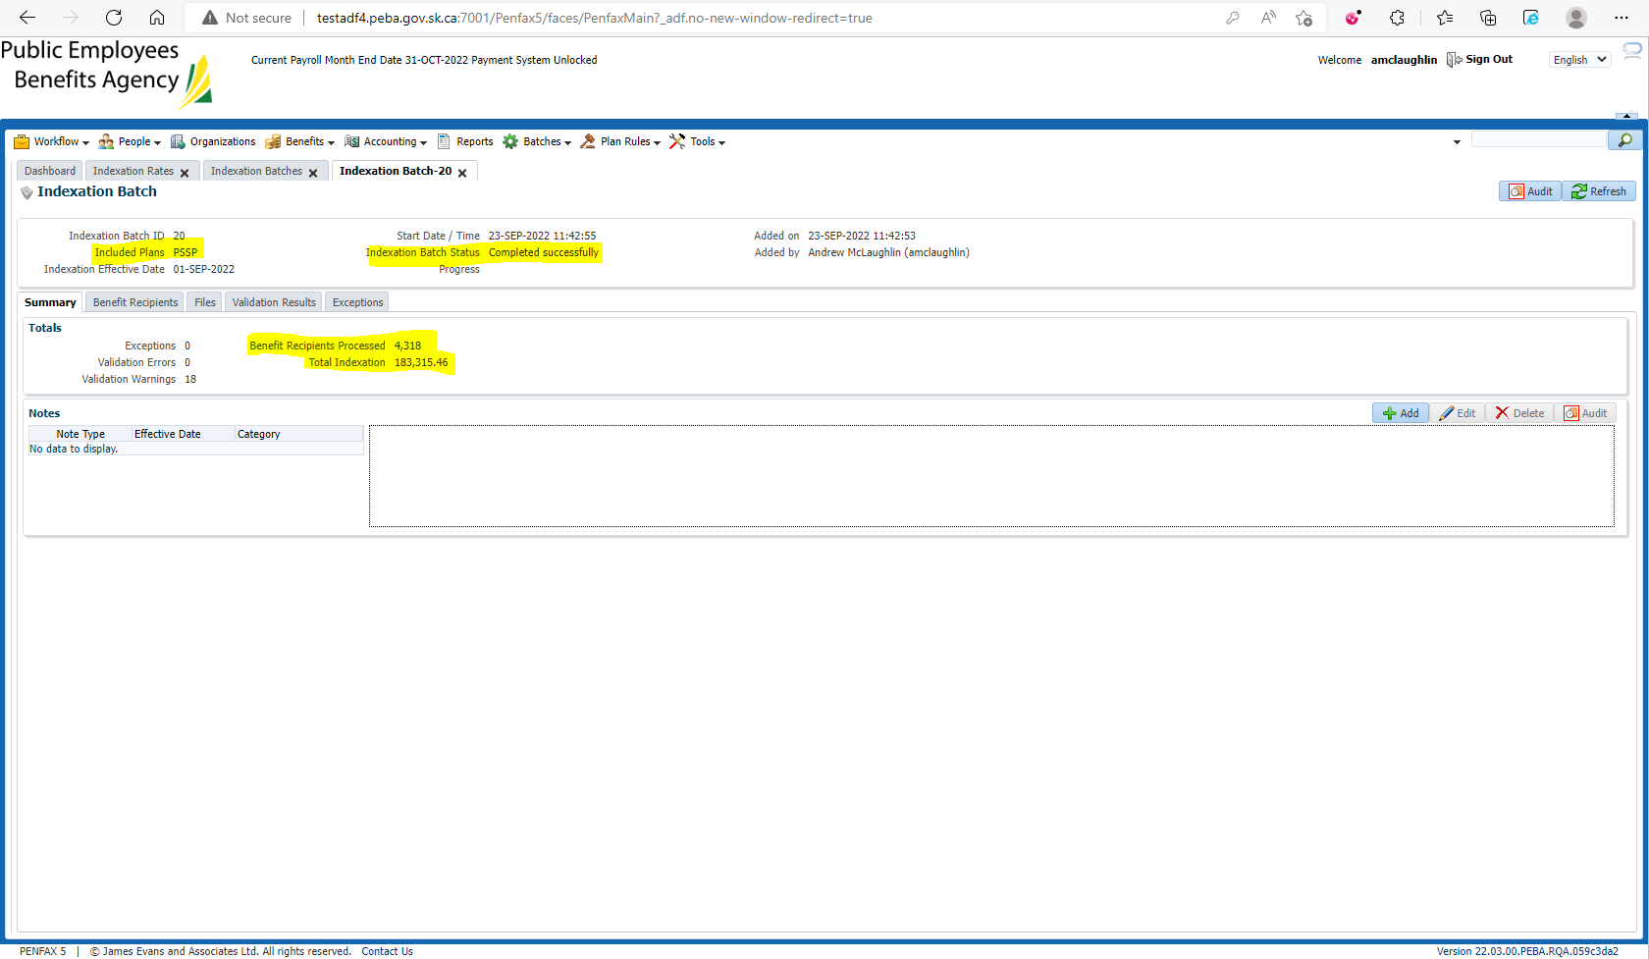

Run post indexing query for PSSP **Query Available on Page 5 here**: H:\Quality Assurance\Prod Apps\PenfaxV5\MEPP\Procedures\How to Run Indexing in Penfax 5.docx

Compare the amounts b/w pre and post indexing query results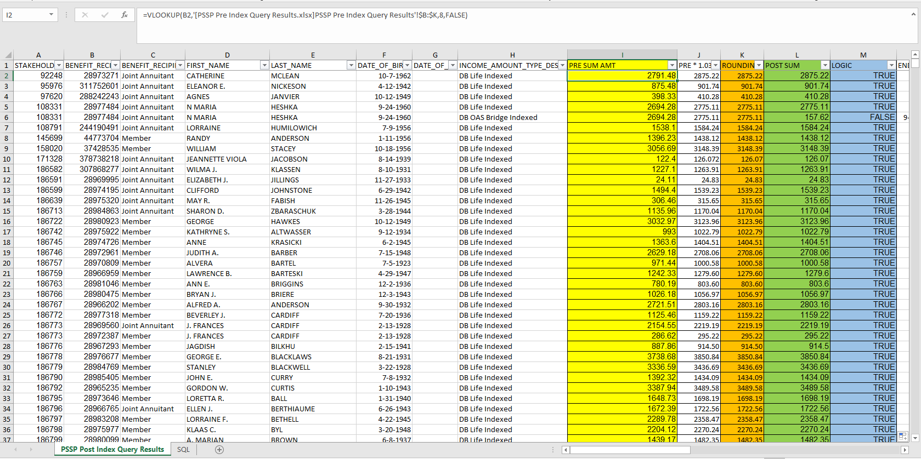

Check a New Retiree during the year 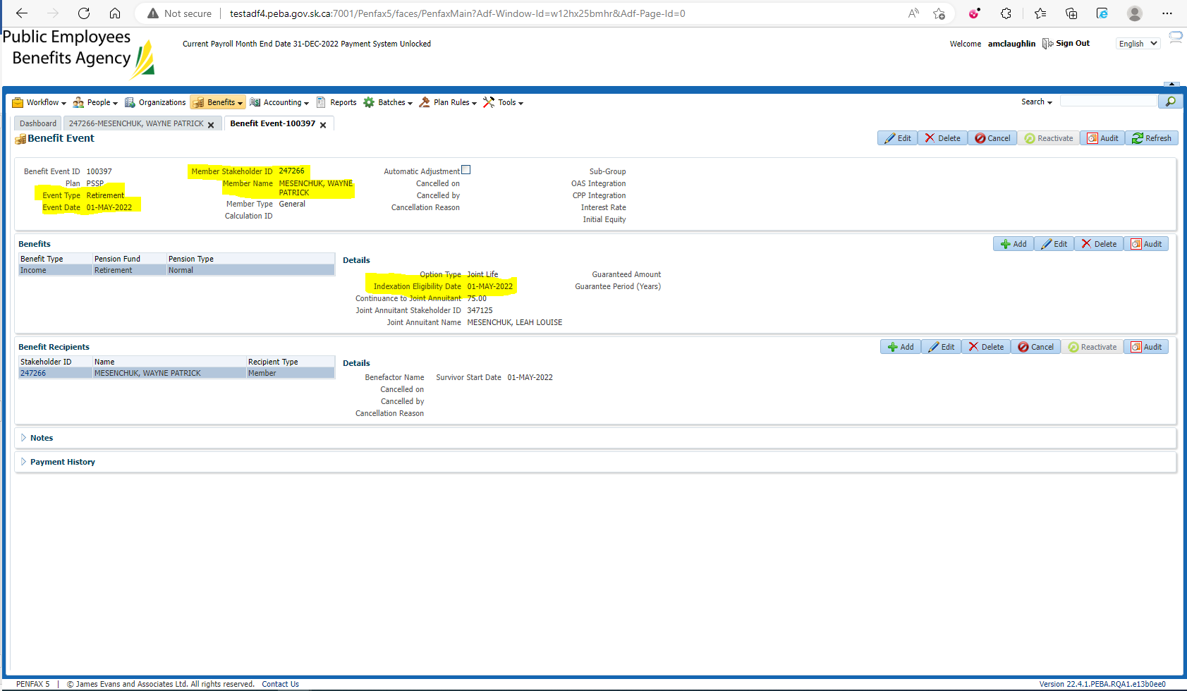

Check Previous Gross Amount: $4,996.48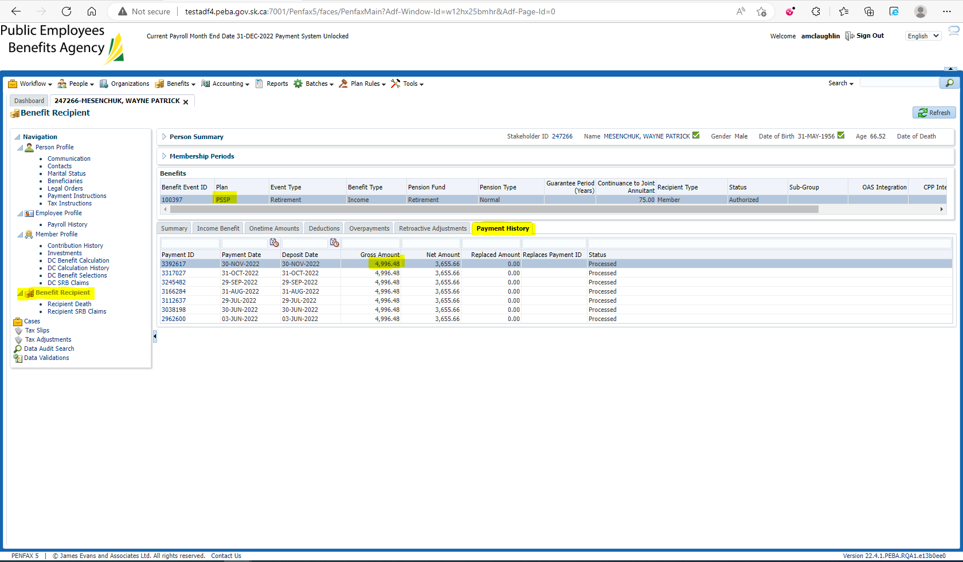

Compared to New Current Amount: $4,996.48 * (1+(0.03*(7/12))) = $5,083.92 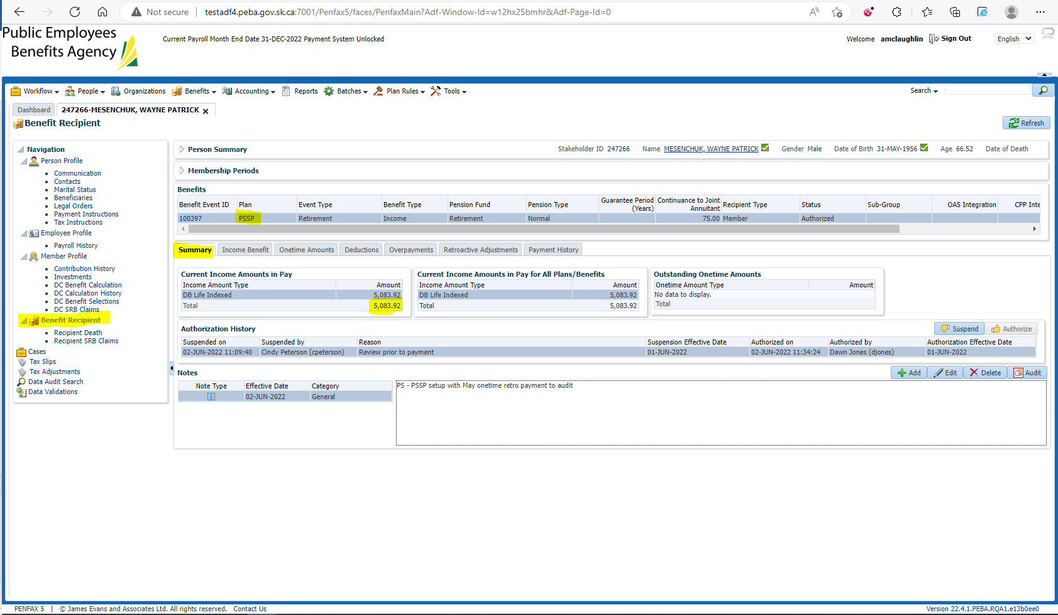

Ensure individual lines in Income have received their increases and are being displayed correctly 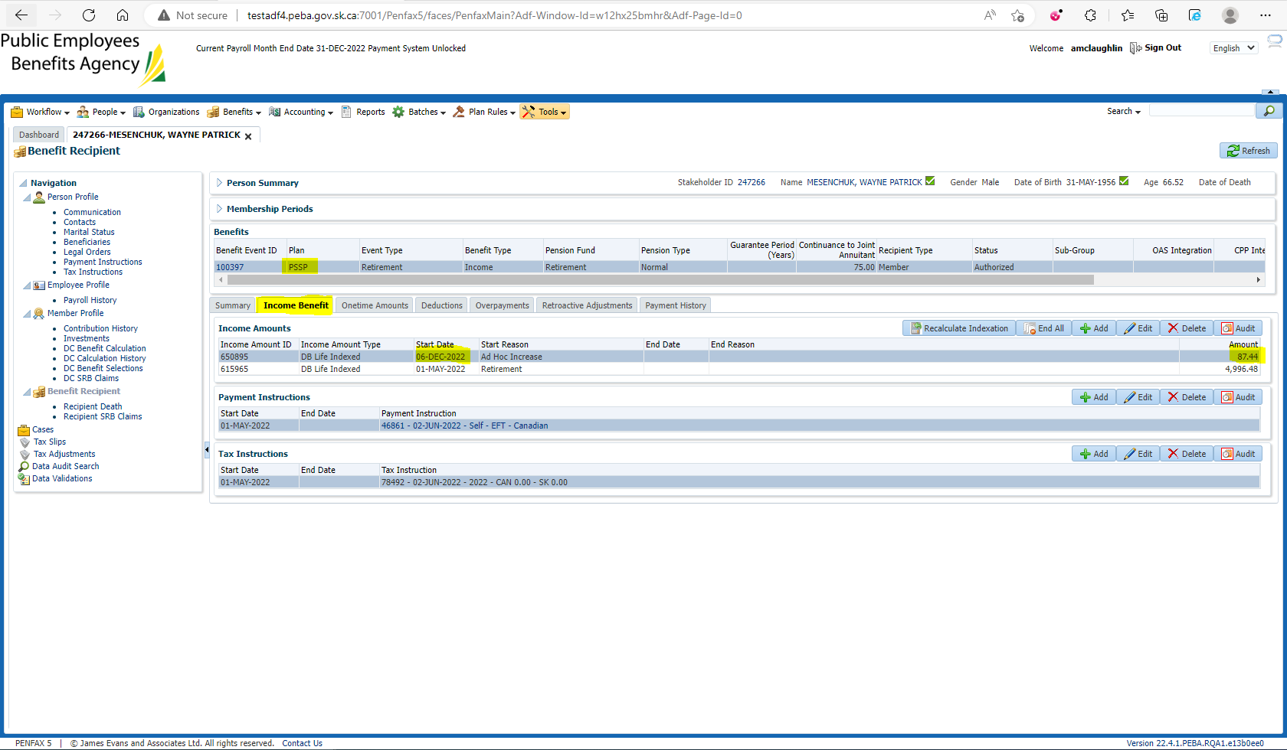

$4,996.48 * 3% * 7 eligible months/12 = $87.44